Expression of Interest (EOI) for Eligible Tourism Assets – Due February 11th, 2021
Kootenay Rockies Tourism (KRT) was recently awarded funding through the StrongerBC Plan Targeted Regional Tourism Initiative (TRTI) to support a variety of initiatives, including the expansion of Destination Level 2 charging infrastructure. KRT has partnered with Community Energy Association (CEA), Fernie office, to support the initiative. CEA has managed the deployment of over 70 Level 2 chargers and 32 DC Fast Chargers in Western Canada.

Building off the existing EV Road Trip itineraries, this project seeks to grow the network of EV charging infrastructure through installation of charging stations at key tourism assets that are municipally, Indigenous or non-profit owned. Strengthening the network will provide an opportunity for the up-and-coming EV consumer market to tour the region and access the many of the signature experiences including hot springs, golf courses, Nordic clubs, museums and campgrounds. This project will contribute to market diversification, namely attracting an urban market from BC, Alberta and the Pacific Northwest, which will support the tourism region's COVID recovery.

Eligible Applicants
Funding is available for tourism assets that are owned and operated by one of the following eligible applicants:
- Municipalities and Regional Districts
- Indigenous communities
- Non-profit organizations

These eligible applicants may own and operate tourism assets including but not limited to:
- golf courses
- nordic centres
- campgrounds
- ski hills
- boat launch and marinas
- parks
- beaches
- attractions, tours, activities
- resorts, hotel, hostel
- commercial hot springs
- Visitors Centres
Privately owned resorts and attractions are not eligible for funding through this Initiative. Please speak with us to learn about other funding opportunities.

Available Funding
Funding has been secured for the supply and install of one Level 2 electric vehicle charging
station for at least 10 site locations where the criteria listed below is met. Considering there is a cost recovery opportunity with the Level 2 charger, please indicate whether your organization is able to provide contribution toward the installation up to $1,000. Expressions of Interest must be submitted by February 11th, 2022.

Up to 2 additional stations can be installed at one site at the expense of the site host (approx. $5,000 per station), which will be procured as part of this Initiative and co-located with the funded station. Please indicate your interest in additional stations in the form below.

Siting Criteria
Eligible site hosts are invited to identify suitable locations at tourism assets throughout the Kootenay Rockies Tourism region (see map at end of document).

In addition to the criteria listed below, Expressions of Interest (EOI) will be evaluated based on the geographical distribution to ensure that the EV Road Trip Itinerary routes are well established.

Further, Expressions of Interest will be evaluated with respect to their ability to bring forth the highest value to the EV Road Trip Itinerary routes.

Minimum criteria for Tourism Asset EV Charging Station Siting:

- Eligible organization owns the land
- Access to 240V, 40 amp service (40 amp required per EV charger)
- Provision of power by site host
- Dedicated parking spot (EV only) with 24/7 access
- $1,000 contribution
- Short walking distance to tourism asset (< 300 m)
- Appropriate lighting and perceived driver safety considerations (i.e., lighting, visibility)
- Minor site preparation, if required (i.e. prep of location, blocking of area pre-construction, etc.)
- Confirmation that the preferred site does not have subsurface utilities, including water, gas or irrigation

Eligible applicant name (organization) :

Key Contact (name):

Phone number:

E-mail:

- Please provide a brief description of your organization’s tourism asset and the specific asset at which the Level 2 charger will be installed (in the case that you own multiple tourism assets in different locations). Please attach additional information as necessary.

- Please describe the specific location proposed for electric vehicle charging infrastructure. If possible, please provide:
  - General description of the site and the associated amenities
  - A photo of the proposed physical location
  - A photo of the associated electrical panel or transformer you propose to connect to
  - The approximate distance between the proposed physical location and the associated building/panel/transformer
  - If possible, an electrician’s confirmation of panel capacity to provide 240V, 40 amp service per requested Level 2 station
  - Estimated daily visits and/or traffic at your tourism asset
  - Number of days per year of operation of your tourism asset, and dates of operation if seasonal

- Successful applicants will be required to sign a Memorandum of Understanding prior to the installation work. Please confirm you understand the following roles and responsibilities as a Level 2 owner/operator. If you have any questions about the points below, we are happy to clarify.

  - Once installed, you are the owner-operator of the Level 2 charging station and will be required to maintain the equipment for a minimum of 5 years
  - Networking fees of approximately $150/year will be invoiced to you by the ‘network operator’ (the communications gateway operator associated with the station, which provides real-time status information, diagnostics and ability to charge for use)
  - You understand there may be a small additional annual fee for station warranty
  - You will be responsible for the electrical costs associated with the use of the Level 2 station. Energy costs are typically about $0.60/hour. You may choose to apply a fee (recommended at no higher than $2/hr), however many site hosts opt to provide charging as a complimentary amenity
  - You will allow for associated signage to be posted recognizing the funding partners
  - The parking stall(s) associated with the Level 2 station(s) will be dedicated to EV drivers only, and will not replace any currently dedicated accessible parking locations
  - The proposed location should also be accessible to users with mobility constraints
  - The proposed location is available 24/7, 365 days per year
  - As the site host owner, you are responsible for day to day maintenance, snow clearing, etc. around the station
  - Commit to providing $1,000 in financial contribution

- Please indicate if you have any questions, comments or considerations not already covered in this application. Please contact us for any clarification required on this EOI process.

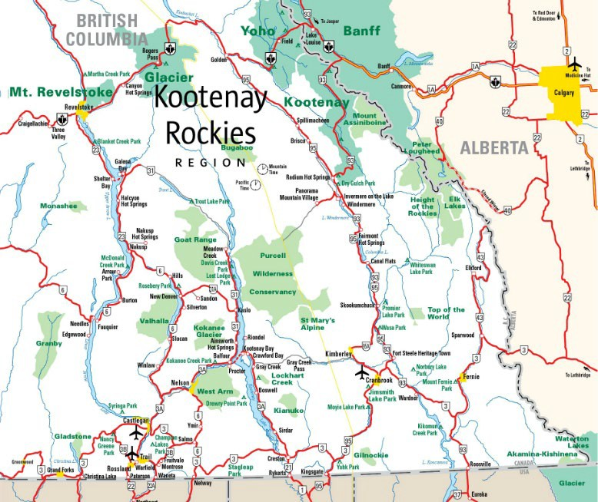

KRT and CEA acknowledge the financial contribution of the government of BC through the Targeted Regional Tourism Infrastructure funding. | For more information:  destinationEV@communityenergy.bc.ca

